Anywhere in the world
2023.02
Python Data Science Notebook
All in One, From All Resources
Sanhyew Ng
Developers freelancing

Preface
B2: §This Book’s “Ecosystem”, page xxxiii.
Python is a popular open source programming language used for both standalone programs and scripting applications in a wide variety of domains. It is free, portable, powerful, and is both relatively easy and remarkably fun to use. Programmers from every corner of the software industry have found Python’s focus on developer productivity and software quality to be a strategic advantage in projects both large and small.

Who this book is for

Prerequisites

What you need for this book

Conventions
In this book, you will find a number of text styles that distinguish between different kinds of information. Here are some examples of these styles and an explanation of their meaning.
• New terms with their definitions are shown in bold italic.
• And important words are shown in bold. Words that you see on the screen, in menus or dialog boxes for example, appear in the text like this: “Clicking the Next button moves you to the next screen.”
• Distinctive terms are shown in Italic font.
• Any subject of explanation is shown with underlined.
• Code words in text, database table names, folder names, filenames, file extensions, pathnames, dummy URLs, user input, and Twitter handles are written in Consolas font as follows:
“Then, run the app using the node app.js command inside the Final directory.”
“This line of code simply uses console.log to print the coinbase by calling web3.eth.coinbase method.”
• Jupyter Code samples are shown in Consolas font on a sky-color shading. When we wish to draw your attention to a particular part of a code block, the relevant lines or items are set in Consolas bold font. And Jupyter outputs are shown in Consolas font on a gray-color shading :
x = torch.tensor(3.0)
y = torch.tensor(2.0)
x + y, x * y, x / y, x**y
(tensor(5.), tensor(6.), tensor(1.5000), tensor(9.))
• Command-line input and output are shown in Consolas Bold and Consolas fonts as follows:
% python
Python 3.3.0 (v3.3.0:bd8afb90ebf2, Sep 29 2012, 10:57:17) [MSC v.1600 64 bit ...
Type "help", "copyright", "credits" or "license" for more information.
>>> ^Z

Part 1. Getting Started

1. Introduction to Data Science
Data Science is a combination of multiple disciplines that uses statistics, data analysis, and machine learning to analyze data and to extract knowledge and insights from it.

What is Data Science?
Data Science is about data gathering, analysis and decision-making.
Data Science is about finding patterns in data, through analysis, and make future predictions.
By using Data Science, companies are able to make:
Better decisions (should we choose A or B)
Predictive analysis (what will happen next?)
Pattern discoveries (find pattern, or maybe hidden information in the data)

Where is Data Science Needed?
Data Science is used in many industries in the world today, e.g. banking, consultancy, healthcare, and manufacturing.
Examples of where Data Science is needed:
For route planning: To discover the best routes to ship
To foresee delays for flight/ship/train etc. (through predictive analysis)
To create promotional offers
To find the best suited time to deliver goods
To forecast the next years revenue for a company
To analyze health benefit of training
To predict who will win elections
Data Science can be applied in nearly every part of a business where data is available. Examples are:
Consumer goods
Stock markets
Industry
Politics
Logistic companies
E-commerce

How Does a Data Scientist Work?
A Data Scientist requires expertise in several backgrounds:
Machine Learning
Statistics
Programming (Python or R)
Mathematics
Databases
A Data Scientist must find patterns within the data. Before he/she can find the patterns, he/she must organize the data in a standard format.
Here is how a Data Scientist works:
Ask the right questions - To understand the business problem.
Explore and collect data - From database, web logs, customer feedback, etc.
Extract the data - Transform the data to a standardized format.
Clean the data - Remove erroneous values from the data.
Find and replace missing values - Check for missing values and replace them with a suitable value (e.g. an average value).
Normalize data - Scale the values in a practical range (e.g. 140 cm is smaller than 1,8 m. However, the number 140 is larger than 1,8. - so scaling is important).
Analyze data, find patterns and make future predictions.
Represent the result - Present the result with useful insights in a way the "company" can understand.

Gathering Data

Data Organization

Data Analysis

Data Visualization

What is Data?
Data is a collection of information.
One purpose of Data Science is to structure data, making it interpretable and easy to work with.
Data can be categorized into two groups:
Structured data
Unstructured data

Unstructured Data
Unstructured data is not organized. We must organize the data for analysis purposes.
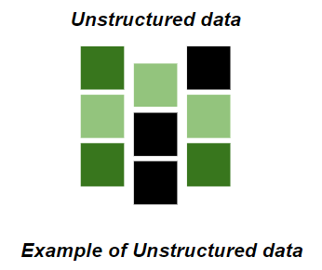
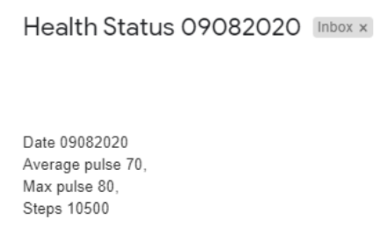

Structured Data
Structured data is organized and easier to work with.
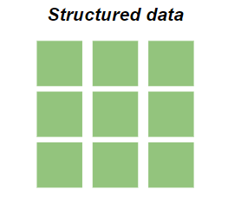

How to Structure Data?
We can use an array or a database table to structure or present data.
Example of an array:
[80, 85, 90, 95, 100, 105, 110, 115, 120, 125]
The following example shows how to create an array in Python:

Example
Array = [80, 85, 90, 95, 100, 105, 110, 115, 120, 125]
print(Array)

2. Preparing the Environment

3. Python Data Science Libraries
Python has libraries with large collections of mathematical functions and analytical tools.
In this course, we will use the following libraries:
Matplotlib - This library is used for visualization of data.
Numpy - This is a mathematical library. Has a powerful N-dimensional array object, linear algebra, Fourier transform, etc.
Pandas - This library is used for structured data operations, like import CSV files, create dataframes, and data preparation
SciPy - This library has linear algebra modules

Matplotlib

Numpy

Scipy

Pandas

Part 2. Image Data

Part 3. Audio Data

Part 4. Time Series Data

Part 5. Tabular Data

Part 6. Text Data

Selected Bibliography

BeginerLevel: Getting Started and Python Language
B1. Programming in Python 3: A Complete Introduction to the Python Language, Second Edition
Mark Summerﬁeld
(Addison-Wesley, 2010, ISBN-13: 978-0-321-68056-3)
B2. Learning Python, Fifth Edition
Mark Lutz
(O’Reilly Media, 2013, ISBN: 978-1-449-35573-9)

Intermediate Level
B3. Python Cookbook, Third Edition
David Beazley and Brian K. Jones
(O’Reilly Media, 2013, ISBN-13: 978-1-4493-4037-7)
B4. The Python Standard Library by Example
Doug Hellmann
(Addison-Wesley, 2011, ISBN-13: 978-0-321-76734-9)
B5. Python Pocket Reference
Mark Lutz
(O’Reilly Media, 2014, ISBN: 978-1-449-35701-6)

Advanced Level
B6. Python in Practice: Create Better Programs Using Concurrency, Libraries, and Patterns
Mark Summerﬁeld
(Addison-Wesley, 2014, ISBN-13: 978-0-321-90563-5)
B7. High Performance Python
Micha Gorelick and Ian Ozsvald
(O’Reilly Media, 2014, ISBN: 978-1-449-36159-4)
B8. Mastering Object-oriented Python
Steven F. Lott
(Packt Publishing, 2014, ISBN 978-1-78328-097-1)
B9. Pro Python
Marty Alchin
(Apress, 2010, ISBN-13: 978-1-4302-2758-8)

